Presentation Title:

Hey - What New with Satir’s Teachings?
The Evolution of the Virginia Satir Transformational Seed Model to a Spiritual / Energy / Efficient / Diplomat Model & Theoretical System
by
Dr. Mary Jo Bulbrook, Dean, Akamai University, Institute for CAM Studies, Program Director, CAM, Founder & President of Energy Medicine Partnerships Intl.
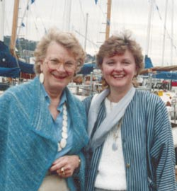
Three inspired occurrences led to the writing of this article for the Satir International Journal. They are: an invitation by Mary Leslie too co-present¹ with her at the Becoming More Fully Human: The Evolution Conference, Celebrating 100 Years of Virginia’s Life & Legacy focusing on the spiritual and energy aspects of her work²; acceptance to present at the research symposium for ISSSEEM Sept. 2016 on the evolution regarding Virginia’s SEED model to be reframed as a Spiritual, Energy, Efficient, Diplomat Model³ and personal inspiration as I meditated on my life’s journey with Virginia. Virginia and starting connecting in the 1970’s when I was completing my doctoral work. I had invited her to write a chapter in my text: Becoming a Therapist for Little Brown which she agreed to do. As our relationship evolved I offered to help her launch her ideas for the University for Becoming More Fully Human. This led to the launching of Avanta Network in Park City, Utah in 1980 in collaboration with the University of Utah where I was director of the psycho-social nursing department. I served on the first board of Avanta Network dedicated to spreading Virginia’s work worldwide. There are many stories connected to our relationship over the years but the major thing I want to report on is all the new energy modalities I learned I did on Virginia – at the end of the day and we would talk about her experiences over the years.
In 1980 the first Satir gathering under the new framework was a four-week therapist training experience combined with personal growth, specific skills and techniques of both didactic and experiential learnings. We held on week annual meeting with 3 weeks process community that attracted individuals throughout the world. We did 19 workshops throughout the state of Utah and had a wonderful time being in relationship over those many days. Some of the topics addressed was body awareness and congruence communication practices were fostered. Learning the triad model of being in a family unit was illustrated and practiced. The triad is the unit of change – you, me and us. – modeling the core family unite. The same principles hold true and is symbolized by the blue flame designed for the first process community in Park City, Utah and holds the energy for that original effort. It is shown here. Blue stands for the throat energy center of chakra and is symbolic of communication which is the hallmark of Virginia’s work… actually communicating beyond words into the spiritual linkages between and among people.
From that vantage point, I built on the Satir Model of Transformation with my entry into the energy therapy world, practicing and teaching several energy modalities worldwide including Therapeutic Touch, Healing Touch, Touch For Health, Energy Medicine, Energy Psychology and Transform Your Life through Energy Medicine my unique training program expanding Satir’s work. What occurred was a blending and expanding language, techniques and insights applying the growing body of knowledge and science in Energy Therapy.
As Virginia and I drove to a TV interview to advertise what she was doing in Park City in 1980, Virginia turned to me and said: “You know Mary Jo, I am a good administrator.” I glanced over at her surprised that she said that. I replied… “of course you are Virginia. Is there any doubt?”
I laugh at remembering that experience now and my surprise at her statement to me. Looking back on that exchange, now I realized Virginia was moving fully into her light and acknowledging the intention and attention to launching her “University for Becoming More Fully Human.” Virginia is and was spiritually oriented. She received insights beyond the five senses which she acted on but did not articulate until the end of her life. She did not have the words to describe her unique multi-sensory abilities that formed the intra psychic exploration into the human condition that affected outward behavior.
Virginia actions were based on a heart connection that reached to the core of her being and that of those she served. She sent love and compassion out into the energy field that in turn influenced those directly involved in the sessions and those participating live in the sessions or later viewing them auditory, video on-line or at other events and reported by others. When the words, emotion, and feelings are united coherently and intimately, a bond is formed that changes others and is sent out into the world through electro=magnetic energy.
Below find Virginia’s description of what she did with everyone no matter what their diagnosis was:
- Examine the feelings and ideas one has about oneself – self-worth;
- The ways people use to work out meaning with one another, which I call communication;
- The rules people use for how they should feel and act which eventually develop into what I call the family system,
- The way people relate to others people and institutions outside the family, which I call the link to society.
No matter what kinds of problem first led a family into my office… I soon found that the prescriptions were the same. To relieve their family pain, some way had to be found to change these four key factors.⁴
How did she do what she did? I suggest it is through the heart connection that produced the changes witnessed, experienced and taught now worldwide. That being said, science now has an explanation why and how that works.
Why is a heart connection between people so important? What does that statement really mean?
I quote Gregg Braden one of the leading scientists and new thinkers of our time about the research regarding the role of the heart in getting to the core of ones being to make changes in the person, family, community and subsequently the world. The heart is the unifying framework of the seemingly “magical” happenings of those who apply the Satir process in the way that Virginia did… that is not merely doing a “technique but rather from an intimate connection touched the “soul” of another person and changing the “life-force energy.”
As we remember with reverence the 15-year episode of the Sept. 9, 2001 disaster it is fitting to quote the research findings surrounding the event. What science documented / the data showed, was that the synchronization of the heart energy worldwide during the disaster showed the science of what is possible as hearts unite around a common cause that includes integrating the mind – feeling and emotions. To listen to this landmark research, describe by Dr. Braden will demonstrate I believe waht the essence of what the Satir Model accomplishes through heart centered connections. The Satir process attaches at the core of our being our heart centers spiritually. The rational of Satirs goal of establishing a University For Becoming More Fully Human actually assists one to become more fully divine through energetic coherence.
Braden states: “On Sept. 9th 2001 scientists able to see how the magnetic fields data through the GOES satellites positioned in the north and south hemispheres measures the readings of the earth’s magnetic energy every 30 minutes. These reading were significantly altered 15 minutes after the first plane hit the tower illustrating how we influence the world through our hearts to influence the fields of the world – it is about the magnetic fields.”
I remember that event and my experience all too well as I watched in real time the striking of the tower after I returned home from walking my dogs. When I watched a replay of the event hours later the energy manifestation was not the same but still very intense all the same. I “felt” the coherence in real time as well as after time – both were energetic manifestations that united my energy to that event and etched memory associations connected to that time frame.
In the video I am describing what Braden said:
“Human emotions extend beyond our human bodies and go out into the field. Science of that time was based on two false assumptions: everything is not connected to things and the other false assumption is that we can alter the world and others through our heart centers. This research of over 300 years is out of date” as what is illustrated in this video by Dr. Braden and measured during this world event shows the Creative Power of the Heart to bring about changes in the world.
Virginia tapped into that unifying concept through her compassion, love and commitment to those she served. This video by Gregg documenting the power of the heart to influence the environment illustrates what we learned from the heart’s electro-magnetic field to “mirror” the internal emotion out into the world.
https://www.youtube.com/watch?v=X1SMqQH7FJU
“When a certain number of people come together can influence the world’s major issues – fully embracing this concept shows that we are linked to the field and what happens in the field can influence creating coherence between our heart and brain such as appreciation, care, forgiveness and compassion can create and feel this can be mirrored in the field…
The heart is the strongest generator of the electromagnetic output into the world and influences all that is. There is a field of reality that influences all things.”
Learning how to tap into that is what Satir did and showed. Today, we have the science and language how that works as described by Dr. Braden in easy to understand terms in this video.
Understanding even just this one piece of scientific evidence brings the Satir framework up to date with current science. That being said Satir also was doing things ahead of her time different from the current way of psycho-social care of individuals. Virginia’s influence as a general systems theory and family therapist outlines her influence as an energy healer. Virginia’s work was / is spiritual getting at the core or the “life force” – it was not just psycho-social care.
Transform means to change completely the appearance or character of something or someone, especially so that that thing or person is improved.⁵ Ludwig von Bertalanffy in the 1950’s created the general systems theory as a way of organizing data universally with applicable principles and laws would hold true regardless of the kind of system under study.⁶
Virginia’s work has been described as a general systems theory of change. From general systems theory to energy therapy is a big change and what I believe Virginia did intuitively – spiritually out of consciousness awareness but was spiritually guided for her ideas and process. For what she did then and what I am proposing, the major difference is using the science of biology and physics that form the background of the mechanism of transformation within the self and community. The Energy Matrix concept incorporates the current thinking about how we are all connected and how change is possible.
Virginia transformed lives using a general systems approach which in fact was simply contacting a person’s spirit achieving “Peace Within, Peace Between and Peace Among,” She challenges us to live congruently:
- To communicate clearly
- To cooperate rather than compete
- To empower rather than subjugate
- To enhance individual uniqueness rather than categorize
- To use authority to guide and accomplish “what fits” rather than force compliance through the tyranny of power.
- To love, value, and respect themselves fully
- To be personally and socially responsible
- To use problems as challenges and opportunities for creative solutions…⁶
I believe we make a difference in the world, a world in which peace is possible when we “love and value ourselves enough and recognize that we are spiritual beings…. Peace begins with me… When one lives peace, the change starts.⁷
“Respect differentness and form bonds based on sameness” is the cornerstone of her teachings.⁷
As these core concepts are lived, experienced and practiced, our field creates a resonance or coherence that goes out into the universe and makes systematic changes beyond the confines of the individual experience. What you think, do, sense when linked together creates and energy manifestation in the world.
So what’s new or expanded from what Virginia said and did? How is it said that she moved from her time as a psychotherapist and leading expert in the care of individuals and families using a unique way that was “different, expansive and effective”. She helped individuals in ways others were not able to reach by the classical ways of her day – she connected through the heart center, at a soul level – connecting spirits through their biofield.
I am proposing Virginia’s work has evolved into the SEED model as Spiritual Energy Efficient Diplomat way of helping individuals, families and organizations change and grow to become more fully human.
Fully embedded with Virginia’s teachings I carried that heritage with me as I entered full time the emerging work of energy modalities. I immersed my life into the current practice, teaching and research of the biofield. This article is just a small taste of what I am going to introduce of the evolved SEED model proposed here. This does not take away from the wording and lineage of Satir’s legacy, it is just that I and many others have expanded her teaching using the current knowledge of our day – which is of course what Virginia would want us to do…
Virginia was not about control and there is only one right way… she believed and fostered the idea the as you plant a seed it grows under the prevailing conditions that it lands on – in this case, the seed from Virginia landed into my heart and embraced all I was learning and added to that to create a new synthesis that has now been used since 1980 in this new way and is even being reframed and highlighted through my inspired insights how Virginia was once again way ahead of her time with her abilities that the world is only now catching up to and languaging and providing the science of why and how what she did works.
To make changes within and without we MUST examine the Life Energy of the person to support transformational changes. This however does not mean we must have the language of the energy system just that we can access it like Virginia did without the energetic language.
What happens to us is controlled by multi-time differences within this life time and beyond. This concept was not well known or accepted in her day. However, in many energy therapies the multi-time frame realities and non-local dimensions of time and reality are address and accessed which was my rationale to reframe the Satir SEED Model based on Energy Therapy innovations.
The science has shown how far we have come in our knowledge and experience of this information. We have moved beyond a disease – rational model of care to an integrated approach to health and healing.
The National Center for Complementary and Integrative Health (NCCIH) include bringing complementary approaches together with conventional health care in an integrative way. Energy Therapy is defined by the National Cancer Institute at the National Institute of Health is defined that a vital energy flows through the human body. The goal of energy therapy is to balance the energy flow in the person and is used to reduce stress, anxiety and promote well-being. These national mandates set a course of relationship of the Satir process with the energy therapy vast network of training programs, approaches and research.
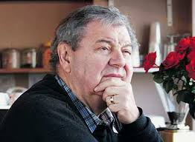
When I first reframed the SEED Model to Spiritual Energy Efficient Diplomat I questioned the two terms efficient and diplomat training. On future investigation I began to see the significance of an energy efficient model since we are open to find more effective ways to go about all that we do in the world. The term diplomat is one who uses a win-win model of congruent communication where the parties interested do not blame one another rather open their energies to new possibilities of connection and working life out. That is the essence of the Satir process as well articulated by John Banman senior holder of the Satir wisdom and I quote: Raise self esteem – level of one’s essence; become a choice maker – to health, happiness, peace and love, become responsible – take charge of your life, become congruent – say what you mean and do what you say.
The five communication stances that Virginia is famous for have been expanded to include the energetic matrixes of them. I will give a short version of them for this article so that you can see the how the work has been expanded to include the energy manifestations in the various communication stances.
People marveled at the incredible changes individuals and families made during Virginia’s work with them. Most were unaware of Virginia’s highly developed ability to perceive information at various levels of consciousness. Virginia’s intuition included visually seeing pictures embedded in the energy fields that surrounds all living things. She did not have the language to explain what she saw only started to act on what came to her. Throughout the years I encouraged Virginia to become more public about her “visions” that helped her become the master teacher she was. She admitted to me that she was afraid that it might jeopardize her standing in the professional community if she would go in the direction as her work had become widespread by that time and she did not want to hinder progress in her mind by talking about things that we so “off the page.” I called her on this choice that she was not practicing what she encouraged us to do which was to speak our truth even when it was difficult to do so.
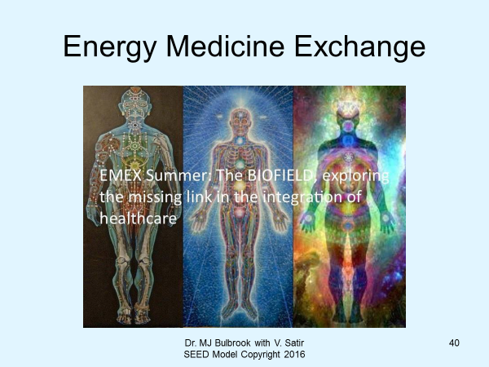
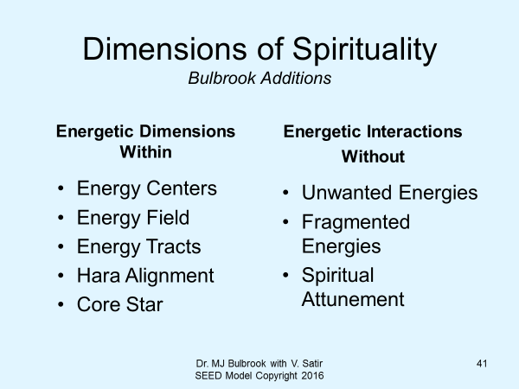
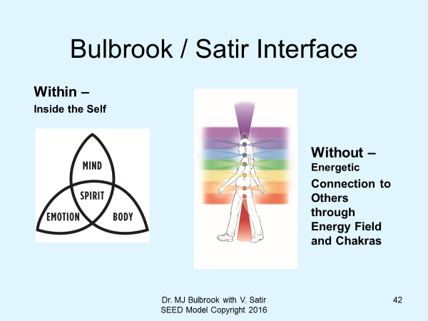
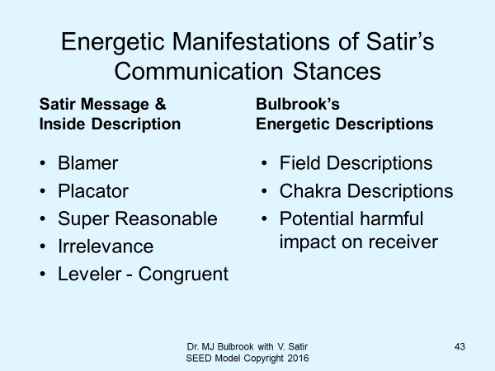
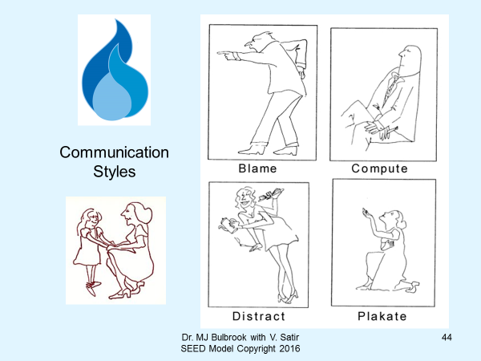
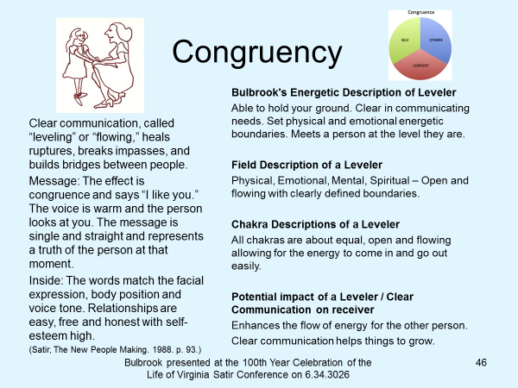
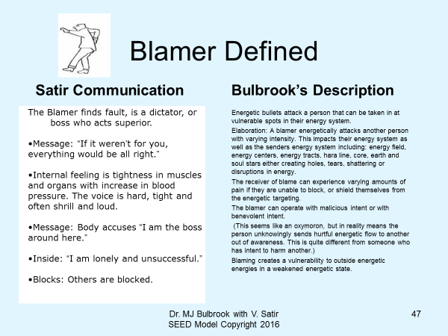
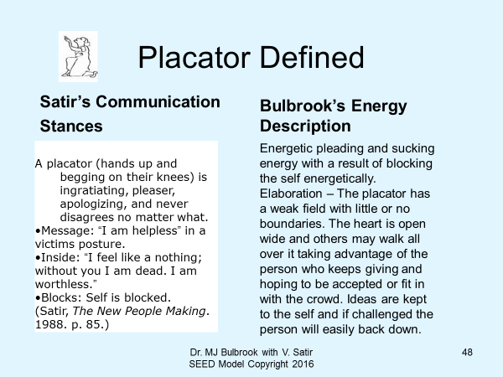
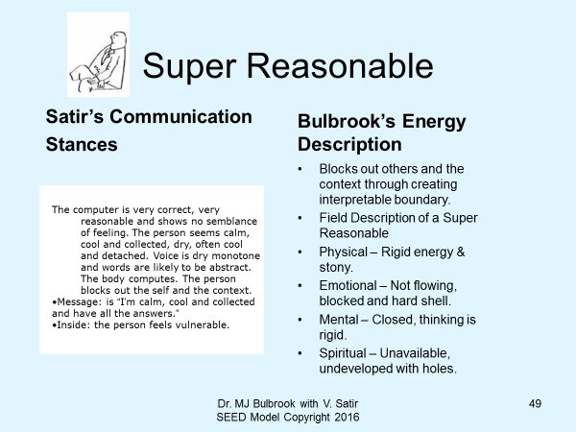

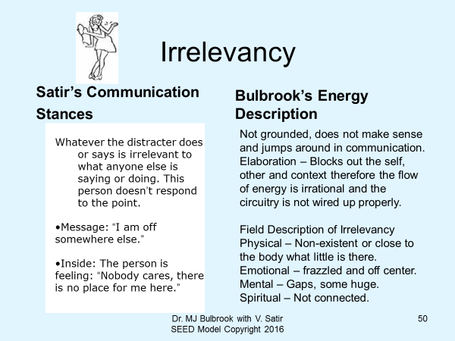
During my time in Perth, Western Australia in 1990 as a Visiting Professor in Nursing I taught and created a series of films integrating Satir work with Energy Therapy. This is included here as background as to synthesis of expanding Virginias work into the energy network. The background is here:
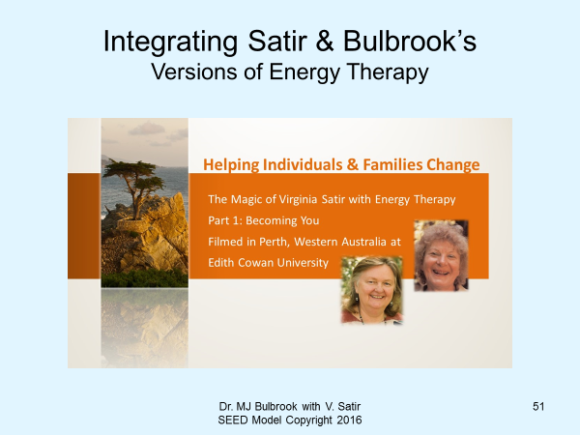
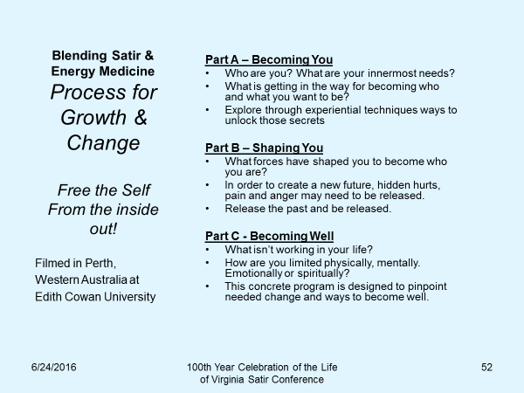
A current application of the synthesis of the Satir process with Energy Therapy is reported from my Aug. 23, 2016 post conference workshop at the Healing Touch Program International Conference on “I Serve Those Who Serve” working with veterans and their families. During the session after an experiential guided meditation process one participant commented that after her husband returned from the Vietnam War he was changed person. Those changes were painful to watch and experience for him, their relationship and two children. He tried to commit suicide and she had to have him committed.
Using the Satir sculpting model of acting out the “client’s story”, what we witnessed acted out was the core issues that service men, women and families are experiencing – the energetic, psycho-social dynamics of the effects of war and fulfilling a service commitment to one’s country. What we witnessed is a major problem facing this country and others. The ravages of was have lasting effects that reach the core of all of our lives that must be addressed. The Satir Model with the addition of Energy Therapy is one tool to combat pain, suffering of trauma.
I knew that I needed to work with the description of the woman’s experience as “family” of served veteran. The pain in her and witnessed by those present was palatable. I switched from my PowerPoint presentation to the lived experience of role playing or sculpture so characteristic of the Satir model. A veteran present played the woman’s husband who was in the war and two sisters present played their two children. As the group watched the dynamics enacted out of the descriptions given the energy within, energy without and beyond was altered. New insights that were sent to those role-playing affected not only themselves but those of us watching, leading and learning how to integrate energy therapy with the Satir change process.
Feedback from the workshop is as follows:
“I honestly had NO idea that there were any healing issues for me as a result of my 25 years of military service. I served as a nurse not a combatant and was in the AF Reserve… The ‘role playing’ was such a revelation… was nothing short of AMAZING! I don’t know if what happened during that event would translate into a healing for AM’s husband and sons… I believe that she, herself, is now in a better place emotionally and spiritually… it is a fact that
Spirit pushed me into your class. May God continue to bless you and your work. PS you have my permission to use this letter in part as a testimony…
Do we make a difference using the Satir process blended with energy therapy? We know the answer to that question… if ONE person is changed… the electromagnetic energy is there available to others to settle their hearts, heal wounds, and get to a new place, after all, that is what we are striving for – Becoming More Fully Human.
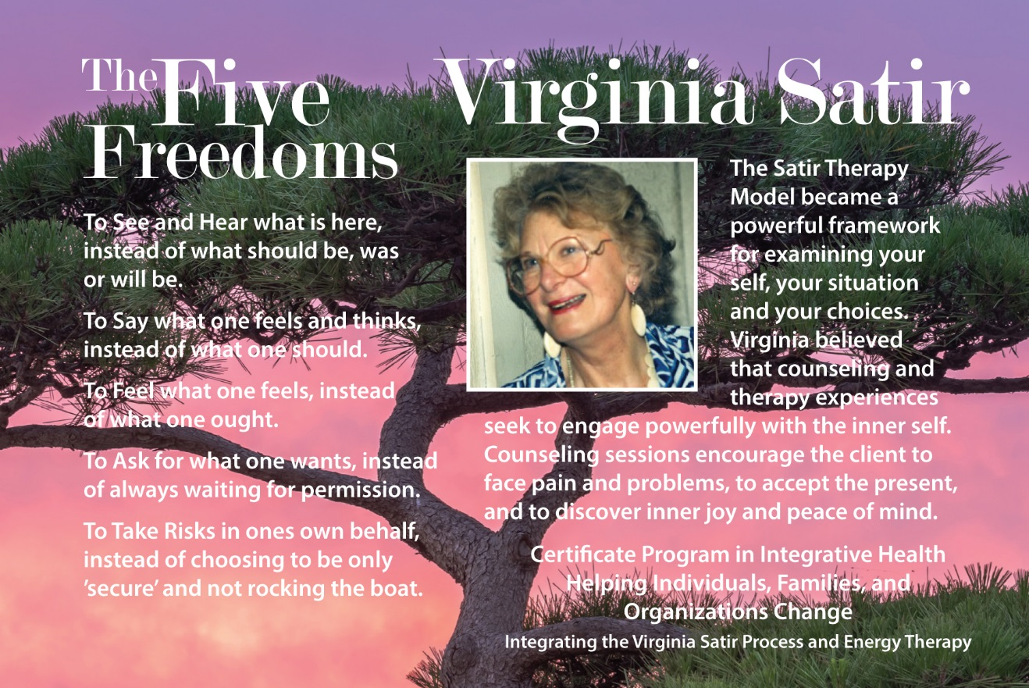

References
¹ Mary Leslie with Guest Presenter, Dr. Mary Jo Bulbrook, June 2016 Widening Our Lens, Deepening Our Practice: An Exploration of Energy Within the Context of the Teachings of Virginia Satir.
² Becoming More Fully Human: The Evolution, A Conference Celebrating 100 Years the Life & Legacy of Virginia Satir June 24 – 26, 2016. Presented by Satir Institute of the Pacific and Sponsored by The Virginia Satir Global Network.
³ Bulbrook, MJ, “The Virginia Satir Transformational SEED Model: A Spiritual / Energy /Efficient / Diplomat Model & Theoretical System for Helping Individuals, Families, Communities & Organizations, Change, Grow and Heal - Becoming All They Can Be, Presented at the ISSSEEM Cf Research Symposium, Sept 21, 2016.
⁴ Virginia Satir, 1988. The New Peoplemaking, Science & Behavior Books, Mountain View, CA. p. 3 & 4.
⁵ Definition from the Cambridge Advanced Learners Dictionary & Thesaurus © Cambridge University Press.
⁶From: http://medical-dictionary.thefreedictionary.com/theory
⁷ Virginia Satir, 1988. The New Peoplemaking, Science & Behavior Books, Mountain View, CA. p. 369-370, 374.
References
Blitzer, C. (1980). “Virginia Satir: Innovator in Family Therapy” Peninsula, May 1980, 37-39.
Bulbrook, MJ, “The Virginia Satir Transformational SEED Model: A Spiritual / Energy /Efficient / Diplomat Model & Theoretical System for Helping Individuals, Families, Communities & Organizations, Change, Grow and Heal - Becoming All They Can Be, Presented at the ISSSEEM Cf Research Symposium, Sept 21, 2016.
Bulbrook, MJ with contributions by Peter Tadd, Intuitive and Private Practitioner in Spiritual Counseling. (1989). “Health and Healing in the Future”: Holistic Health and Its’ Relationship to Virginia Satir, Family Health and Family Therapy.”, Teaching Materials Holistic Health Family Center, St. John’s Newfoundland, CA.
Bulbrook, MJ, Film Series 1990 from Perth, Western Australia at Edith Cowan University titled Healing Individuals and Families Change based on the combination of the work of Virginia Satir, renown expert in family care with Dr. Bulbrook’s pioneer work in body, emotion, mind and spiritual health and healing titled: Healing From With and Without. The three-part series is: Becoming Your, Shaping You and Becoming Well has original film footage of Satir at the University in the 1970’s that was interwoven into Dr. Bulbrook’s filmed theoretical model.
Bulbrook, Mary Jo 2000 Healing Stories: To Inspire, Teach and Heal. Healing Touch Partnerships, Carrboro, NC.
Learning Healthy Ways to Say Good-Bye to Loss and Change, Presented Third International Intensive Care Nursing Conference, Montreal, CA 1988
Bulbrook, MJ, How Do You Tell A Healthy Family? Based on the Teachings of Virginia Satir Presented at SouthEast Institute for Group and Family Therapy with content from Satir, V. 1988 The New Peoplemaking. Science & Behavior Books, Mountainview, CA
Bulbrook, MJ April 2007 Presentation Association of Comprehensive Energy Psychology, Annual Meeting Blending Virginia Satir with Energy Medicine
Chase-Marshall, J. (1976). “Virginia Satir: Everybody’s Family Therapist.” Human Behavior, September 1976, 25-31.
Chung, C. (2016). “The Effectiveness of a Satir-based Personal Growth-Workshop among Chinese People. Presented at the Becoming More Fully Human: The Evolution Conference.
Dodson, L. (1991). “The Dying Process of a Conscious Woman—Virginia Satir.” In Barbara Jo Brothers
(Ed.), Virginia Satir: Foundational Ideas (pp. 179-187). Binghamton, NY: Haworth Press.
King, L. (1989). Women of Power. Berkeley: Celestial Arts.
Laign, J. 1988). Healing Human Spirits: Master Therapist Virginia Satir.” Focus on Chemically Dependent
Families, October/November 1998, 20-31.
Loeschen, S. (1991). The Magic of Satir: Practical Skills for Therapists. Long Beach, CA: Halcyon.
Rowe, D. (1978). Virginia Satir Interview.” New Forum, The Journal of the Psychology and Psychotherapy Association, Spring 1978, _____.
Russell, D (1990). “A Conversation with Virginia Satir.” University of California Santa Barbara, Davidson Library Special Collections.
Satir, V. (1983). Conjoint Family Therapy. Palo Alto, CA: Science and Behavior.
_______(1997). Making Contact. Berkeley, CA: Celestial Arts.
_______(1975). Self-Esteem. Berkeley, CA: Celestial Arts.
_______(1988). The New Peoplemaking. Mountain View, CA: Science and Behavior.
_______(1996). The Third Birth—Becoming Your Own Decision Maker. Burien, WA: Avanta.
_______(1987). Your Many Faces. Berkeley, CA: Celestial Arts
Satir, V. & M. Baldwin (1983). Satir Step by Step. Palo Alto, CA: Science and Behavior.
_______(1987) The Use of Self in Therapy. New York: Haworth Press.
Satir, V., J. Banmen, J. Gerber & M. Gomori (1991). The Satir Model. Palo Alto, CA: Science and Behavior.
Schwab, J. A Resource Handbook for Satir Concepts. Palo Alto, CA: Science and Behavior.
Scully, C. (1975). “Family Theatre.” People 3:1, Fall 1974/Winter 1975, 11, 20.
Zahand, W. (2015) “The Human Kaleidoscope: I AM.” Teaching Manuel Based on the Teachings of Virginia Satir Including Personal Conversations with Wally at the June 2016 Conference in Vancouver.
Virginia Satir’s Legacy: Highlights of Virginia’s Life and Practice.
Michele and Bud Baldwin, Joan Winter, Through the Family and Beyond: Full Esteem Ahead: A Tribute to Virginia Satir. Santa Clara, CA, August 1991.

