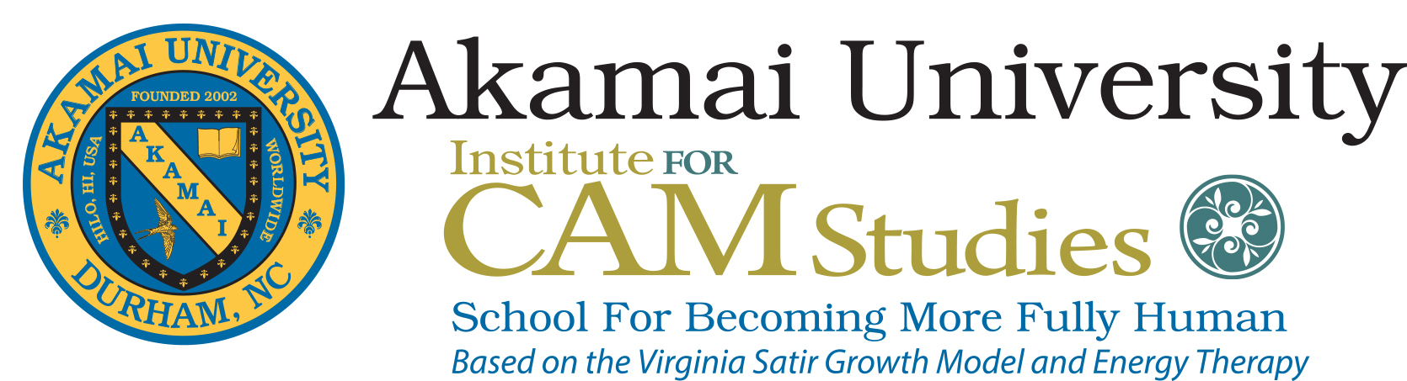
Akamai University Website
A Certificate Program in Integrative Health:
MJ Bulbrook’s Energy Therapy & Virginia Satir’s Growth Process
Helping Individuals, Families & Organizations Change
Offered through Energy Medicine Partnerships
Affiliated with Akamai University – Institute for CAM Studies - Division of Continuing Education
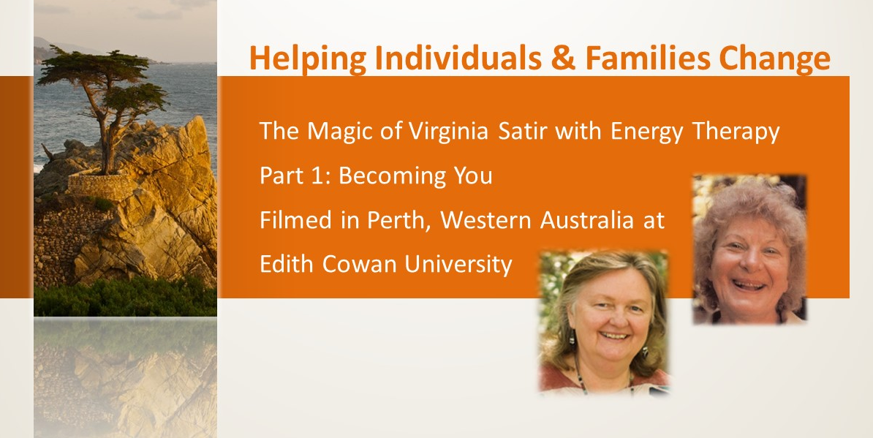
Background: Virginia and Mary Jo’s lives began to touch as Mary Jo studied Virginia’s work as a doctoral degree student at North Texas State University focusing on becoming a clinical specialist in psychiatric mental health nursing and with a specialty in child psychiatry. From that original contact Virginia agreed to write a chapter in a book Mary Jo was writing on Development of Therapeutic Skills, published by Little Brown, Co 1970. Their paths kept intersecting as they embarked on studying energy therapy separately, then together. There are a series of 5 films of their joint training called Helping Individuals and Families Change based on these combined teachings.
Mary Jo dedicated her early professional years supporting Virginia’s dream of launching her teaching legacy in 1977 that was called Avanta Network. She served on the first Governing Council of Avanta Network and coordinated the first training of Avanta Network held in Park City Utah in 1981 with the University of Utah where Dr. Bulbrook was Director of the Psycho-Social Nursing Department. The blue flame shown below is a replica of the original symbol used for Avanta Network and was designed in gold for this effort.
In June 2016, Mary Jo was invited to present her experiences with Virginia blending Energy Medicine and Energy Therapy with Mary Leslie called: “Widening Our Lens, Deepening Our Practice: An Exploration of Energy Within the Context of the Teachings of Virginia Satir at the 100th Anniversary of Virginia’s life & legacy in Vancouver, Canada. This launched Mary Jo’s reconnecting with the legacy of Virginia now call The Virginia Satir Global Network.
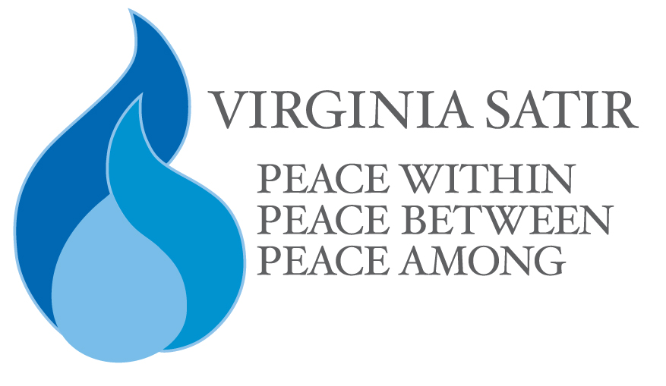
Certificate Program Goal: This worldwide training program prepares Integrative Health Diplomats: Becoming More Fully Human - Blending MJ Bulbrook’s Energy Therapy & Virginia Satir’s Process – Helping Individuals, Families, Communities & Organizations Change. An Integrated Health Diplomat is defined as a person trained in the methods of world leader and family psychotherapist Virginia Satir blended with MJ Bulbrook’s Energy Therapy to skillfully facilitate congruency communication with individuals to achieve Peace Within, Peace Between, and Peace Among. Virginia’s teachings have received worldwide acclaim for supporting change and helping people find ways to live in harmony in the self, others, and context, working out differences.
This training can also be used as foundational training for other CAM degrees at Akamai University. AU is an internationally accredited Distant Education Institution of Higher Education. Definitions used for this program such as Integrative Health and Energy Therapy are nationally defined through official US governmental bodies.
Integrative Health defined by the World Health Organization in 2008 definition is used for this educational program.
Integrative Health involves bringing conventional and complementary approaches together in a coordinated way as defined by the National Center for Complementary and Integrative Health (NCCIH) the US Federal Government’s lead agency for scientific research in these areas.
Energy Therapy is defined by the National Cancer Institute at the National Institute of Health:
Energy Therapy is a form of complementary and alternative medicine based on the belief that a vital energy flows through the human body. The goal of energy therapy is to balance the energy flow in the patient. It is used to reduce stress and anxiety and promote well-being. Currently Energy Therapy is being studied in patients receiving cancer therapy, to find out if it can improve the quality of life, boost the immune system, or reduce side effects. It is also called Energy Healing.

This Certificate Program achieves the goal of integrating current mental health approaches to health and wellness, using the internationally recognized Virginia Satir’s Process for Helping Individuals and Families Change with MJ Bulbrook’s Energy Therapy.
Experience the magic of Satir’s philosophy in action with Bulbrook’s Energy Therapy that Virginia and Mary Jo shared in their 16-year professional and personal history as colleagues & friends committed to facilitate Peace Within, Peace Between and Peace Among. If you want to make changes in the world, your community, your family and within yourself, this is the place to reach your dreams.
Join Mary Jo and faculty of experts in Energy Therapy and the Satir Method in the operationalized her dream come true for focused education on spirituality and Satir growth model housed in the Institute for CAM Studies. Join the training model of Satir Becoming More Fully Human. Experience Freedom to be all you can be from your deepest heart wish.
Virginia Satir 1988 Quotes p.336 The New Peoplemaking
“The challenge of becoming more fully human is to be open to and to contact that power we call by many names, God being one frequently used. I believe that successful living depends on our making and accepting a relationship to our life force.”
”I consider the first step in any change is to contact the spirit. Then together we can clear the way to release the energy for going toward health. This too is spirituality in action. P. 341
Peace Within, Peace Between, and Peace Among Satir 1988 p. 368 & 369
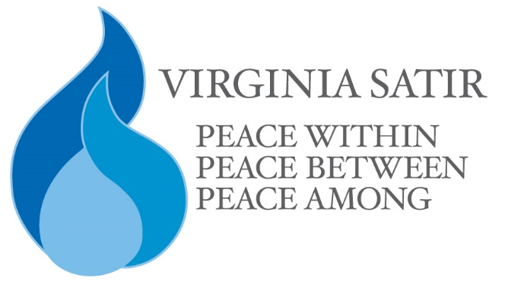
“Creating peace in the world strongly resembles making peace in the family. We are learning how to heal families, and we can use those learnings to heal the world.
Our global family is dysfunctional and, in effect, operates with the same themes as any other dysfunctional family.
In many governments, power is concentrated in one person or role. Identity is seen in terms of conformity and obedience and autonomy is subject to someone else’s approval. In and between countries conflict is often dealt with by blame and punishments. Solutions are reached by decree, threat, force, conflict, war, and avoidance. Trust is frequently betrayed and therefore suspect. Relationships are based on dominance and submission rather than love, compassion respect and value for each other.

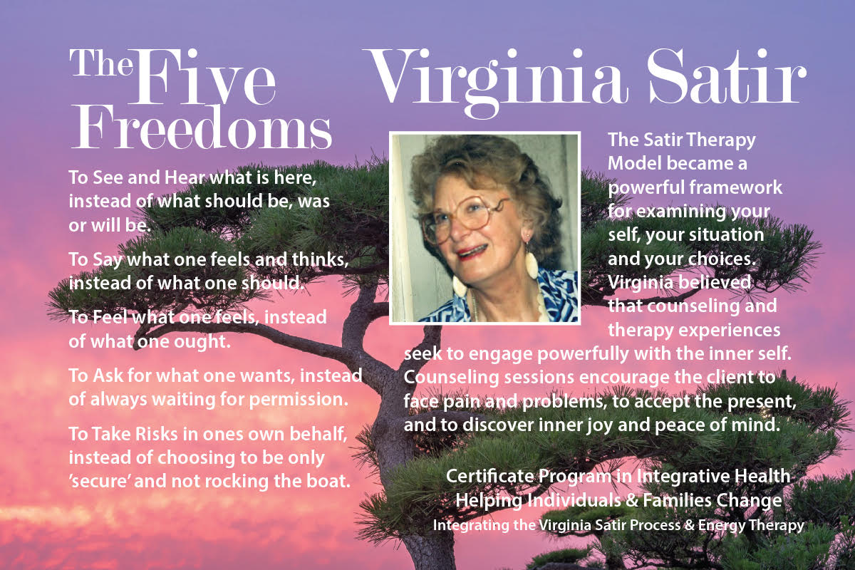

These goals are achieved by congruent living principles:
- To communicate clearly
- To cooperate rather than compete
- To empower rather than subjugate
- To enhance individual uniqueness rather than categorize
- To use authority to guide and accomplish “What fits” rather than force compliance through the tyranny of power
- To love, value and respect themselves fully
- To be personally and socially responsible
- To use problems as challenges and opportunities for creative solutions”
What will cause each of us to change our minds? I believe it will be when we love and value ourselves enough and recognize that we are spiritual beings.
This training is core curriculum for all levels of training offered through the Institute for CAM Studies. The focus is on bring forward your deepest wishes for your professional career path and personal life. Our goal is to support your deepest dream as supported by your spiritual guidance in collaboration with the Institute and Dr. Bulbrook who is dedicated to build a personal studies program for you that is enriched with Satir’s vibrant, magical approach to supporting individuals, families, communities, and organizations grow, heal and change.

How is this training different and the same as other Satir training.?
As Virginia said: “We connect through our sameness and grow from our differences”
We are living in a historic time. “A new evolution to humankind is afoot. All people who are working toward becoming more fully human will be bridges to that new time. We are the transition people…It is urgent that we nourish and develop the buds of sanity and humanness that are emerging. What we have going for us is a fantastic know-how of technical development and proven intellectual ability. We know how to probe and investigate practically everything. Our challenge now is to develop human beings with values – moral, ethical, and humanistic that can effectively utilize this development. When we achieve that, we will be able to enjoy this most wonderful planet and the life that inhabits it. WE ARE ON THE WAY. Satir 1988: The New Peoplemaking p. xi
This certificate training blends Bulbrook’s Energy Therapy with the Satir Model for Becoming More Fully Human in a university setting with opportunities for advanced training, clinical practice, research, and teaching weaving spirituality, humanistic, holistic, bio psycho-social – spiritual integrated model of care and caring. It addresses classical Satir training blended with energetic approaches to health and healing that Mary Jo and Virginia talked about and practiced together starting in early 70’s until Virginia’s death in 1988.
Use this Certificate in Integrative Health as a basis for continued studies for Bachelors, Masters and Doctoral Education in Complementary and Alternative Medicine from a team of educational specialist, researchers and clinicians in both Energy Therapy & Satir Growth Model who have come together in their sameness and differentness to provide an enriched educational opportunity to grow and change professionally and personally.
This training is based on MJ Bulbrook’s Transform Your Life through Energy Medicine, available to integrate with other Energy Therapies such as: Energy Psychology, Energy Dynamics, Bio-energy Feedback, Transpersonal Studies, Integrative Health. No matter what you goal is: Clinician, Teacher, Researcher, Coach, Family Therapist, Health Care Professional or Personal Development, we will work to find opportunities to achieve your individual interests.

Energy Therapy has become an integral part of society and the educational system. It offers a perspective that supports all cultures, all religious traditions, and all health conditions. It is a key element revolutionizing & affecting health care in the future.
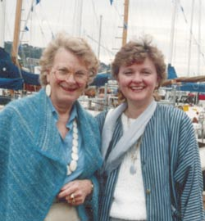
Virginia and Mary Jo in Seattle 1980
Virginia Satir 1916 – 1988 Celebrating 100 Years of Virginia’s Legacy, Vancouver, BC, June 2016
The late Virginia Satir is a pioneer and expert in innovative ways to help individuals and families change and heal using great skill in diplomacy and healthy congruent communication. Her magic reached throughout the world and touched the lives of individuals, families, professionals, and organizations from many countries.
Her far reaching influence shaped the world of psychotherapy - mental health and wellness globally. Her legacy lives on and continues to impact the world. She is best known for her work on Self Esteem, Whole Person Learning, Family Reconstruction, Your Many Parts, Five Freedoms & Congruent Communication.
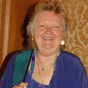
Dr. Mary Jo Bulbrook, RN, CEMP/S/I, HTCP, ICF President of Akamai University as of Feb. 1, 2021 Dean, Integrative Health College & Institute for CAM Studies, AU President & Founder, Energy Medicine Partnerships
Psychotherapist & Family Therapist, Spiritual Intuitive, Master Teacher & Practitioner in Energy Based Therapies including Transform Your Life through Energy Medicine, Healing Touch and Touch for Health, & Energy Psychology. Mary Jo communicates multi-dimensionally.
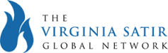
Dr. Bulbrook is Program Director of Complementary & Alternative Medicine and Dean of the Division of Continuing Education at Akamai University where this program is housed. Coordinator of Virginia Satir launch of Avanta Network. The First International Meeting was held in Park City, Utah in 1981.
Avanta Network has evolved into The Virginia Satir Global Network. Become a Professional Member of Satir Global Network and see the many resources available to support your journey. https://satirglobal.org/ office@satirglobal.org phone 206.241-7566 / 7301 Indian Rock Rd. Wendell, NC 27591

Satir & Bulbrook Becoming More Fully Human Training
- Capture the Story of Virginia & MJ’s original contact & present-day alignment
- Learn “Helpful Talk” & “Compassionate Listening,” to support individuals, families, communities and organization
- Practice Bulbrook’s TYLEM interventions and other integrative (whole person) energy therapies
- Evaluate effectiveness of the Integrative Health Energy Therapy applied to select populations
- Provide expert care, support, acceptance, unconditional love & healing to individuals their families, friends, and health care professionals
- Design marketing materials for your work
- Create a personal self-care program to maintain health & model wellness
- Commit to up-dating training and refinement of your knowledge & skills
- Describe the ethical dimensions in providing care
- Explore literature, research & practice in Integrative Health, Energy Therapy, & Energy Healing
- Integrate expertise from energetic clinical skills with bio-psycho-mental-social-spiritual wellness
- Promote understanding and acceptance of Integrative Health, Energy Therapy & Virginia Satir Process
Continuing Education Units: This Integrative Health Certificate Program consists of 9 Continuing Education Units or a minimum of 90 to 120 hours of training and clinical supervision that leads to a Certificate in Integrative Health: Bulbrook’s Energy Therapy with Virginia Satir’s Process for Helping Individuals, Families and Organizations Change & Heal to become an Integrative Health Diplomat.
Whole Person Learning - Energy Therapy Curriculum:
- Part I – Preparation for Integrative Health Certificate: Bulbrook Energy Therapy & Satir Process
  - Introduction seminar – 3 contact hours
  - Initial Diplomat training - 9 contact hours
  - Bulbrook Energy Therapy / Satir Interventions – 21 contact hours
  - Ethical dimensions in caring for individuals & families = 3 contact hours

- Part II - Clinical Practicum, Documentation & Evaluation supervised with a Mentor
  - 30 contact hours done over time with clients & families (more hours may be required depending on the ability of the individual in training to be successful in carrying for individuals, their families, friends & health care professionals or with organizations
  - 20-hour minimum studying the literature on Energy Therapy & Satir Training
  - 10 hours’ minimum supervision of your Diplomatic service & practice

- Part III – Certification through the CAM Academy – Documentation of service / practice as verified by an outside review body the ensures safe, ethical practice operating under a Code of Professional Conduct = 3 contact hours

Program Fees: Costs: Part I Introduction Special – 3 contact hours $75, Total Program Cost with Mentorship & Supervision: Special Introductory Rate during Covid 19 pandemic– Limited time program paid in full: $1800 (usually $2100 for the training). Includes university continuing education with international accreditation, core specialist training, modules, practicum, certification, and mentorship. Total of minimum of 150 – 175 contact hours. Additional fees will be charged for mentorship and supervision as needed beyond program content. That fee is $25 for 15 minutes.

All fees are payable to Institute of CAM Studies. Includes University credit through Akamai University Division of Continuing Education. After each segment, a certificate of CEU’s will be awarded documenting the segment taken and the number of contact hours. Payment options are available. Limited number of scholarships available for qualified individuals. Exchange for service required for scholarship awards. Part I training also available as stand-alone costs without registration for the whole program. Modules are $75 each for stand-alone 3 contact hour courses. Then payment schedule for the remainder of the fee if not paid in full. $25 will be charged per installment over and above the fee. A repeater fee for courses and modules is one/half the cost of each segment. At the completion of the program a Certificate as a Integrative Health Diplomat / Specialist in Helping Individuals, Families & Organizations Change through the Virginia Satir Process & Bulbrook’s Energy Therapy. Contact hour certificates will be awarded for each course taken and program certificate as a Integrative Health Diplomat once the whole curriculum is completed.

Certificate Program Objectives: Participants will:
- Describe the Virginia Satir Process and MJ Bulbrook TYLEM Therapy.
- Explore the elements of Integrative Health with TYLEM.
- Describe the ethical dimension of clinical work.
- Investigate Integrative Health Approaches with Other Energy Therapies.
- Practice Integrative Bulbrook Energy Therapy & Satir Process Interventions.
- Treat, support and care for individuals, families and organizations using the protocol process in integrating the training with your previous professional work.
- Document treatment outcome.
- Create professional marketing materials for your practice as a Diplomat in Helping Individuals, Families & Organizations Change.
- Promote understanding and acceptance of the needs of individuals, families, and organizations.
- Participate in a community of colleagues to maintain expertise.
- Practice mindfulness, and healthful living approaches modeling respect for the self, and others.
- Explore diplomatic strategies with an open mind to improve meeting integrative health needs in dealing with others, by being respectful and able to achieve peaceful resolutions and / or facilitate win-win discussions and planning.

Eligible Participants for the Training: The training is open to anyone desiring to become a Certified Specialist / Diplomat in Integrative Health: Blending the Virginia Satir Process Helping Individuals & Families Change with Bulbrook’s TYLEM and other Energy Therapies if desired. This program includes being willing to undertake the in-depth study; commit to high standards of practice; operating under a Code of Ethics; receive on-going mentorship and supervision as needed both in the initial training; maintain competency and updating knowledge and skills as needed. This is an on-going growing field.
Mental health and general health care professionals are encouraged to apply as well as energy practitioners. This training is foundational for those who desire to be practitioners and / or teachers of this training, mentors, and supervisors. A portfolio assessment is acceptable to waive training requirement and for accepting transfer in credit for previous expertise.
Integrative Health Diplomats or Specialist operate under a Code of Ethics, Standards of Practice, with Certification through the CAM Academy
Guiding Principles:
- Let Go and Let God
- Spiritual Healing Heals
- Be Present & Quiet to Hear Inner Wisdom
The Healing Journey in Integrative Health: Helping Individuals and Families Change Integrating the Virginia Satir Process & Bulbrook’s TYLEM Energy Therapy is not a linear path, but a dynamic lived experience unique to the individuals involved. Therefore, the interventions for body, emotion, mind, and spirit need to be individualized to those involved using a template that to guide the educational team. Training for support is offered by CAM Specialists & Satir trained in the protocol designed by Dr. Mary Jo Bulbrook and based on the Satir Process for Change & Becoming More Fully Human.

For More Information, Contact:
Dr. Mary Jo Bulbrook, Headquarters: 3211 Gibson Rd, Durham, NC 27703 Phone 1.919.381.198 / cell 1.919.923.2409 mj.bulbrook.au@gmail.com / mj.bulbrook@akamaii.university
www.energymedicinepartnerships.com
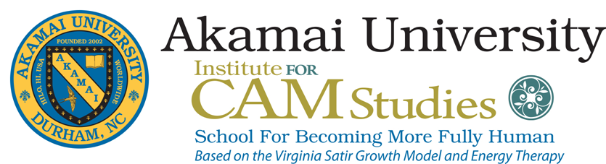
https://www.globalhealingalliance.com/virginia-satir-networking.html CAM Studies at Akamai University Website

