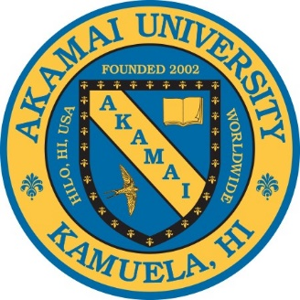
Akamai University
AU Administration Headquarters: 3211 Gibson Road, Durham, NC 27703-4766
mj.bulbrook@akamai.university / info@akamai.university
AU Administration Office / 1.919.724.9657
Board of Directors & Officers:
Dr Mary Jo Bulbrook, Akamai University Board President - Chief Operating Officer
3211 Gibson Road, Durham, NC 27703, USA
Ph 1 (919) 724.9657 (o) / 1 (919) 923 2409 (c) / mj.bulbrook.au@gmail.com
Dr. Medani Bhandari, Senior Vice President - Chief Academic Officer / Executive Officer
13353 Foxhole Dr. Fairfax, VA, 22033-1336 USA Ph. 1.240.505.1469 / Email medani.bhandari@gmail.com
Dr. Niranjan Ray, Vice President - University Development
9825 Lubao Avenue, Chatsworth, CA 91311
1 (818) 599-5836 / nray99@gmail.com
Dr. Owen N. Owunwanne, Phd- Secretary / Treasurer / Executive Officer
2110 Dexter Ave. Suite 201, Silver Spring, MD 20902 1.301-593-4719 / owenonjo@aol.com
Dr. Douglass Capogrossi - President Emeritus, University Historian
Jackson House, 211 on 1818 Pacific Avenue, Everett, WA 98201
Ph. 1 (808) 339-4605 (c) / 1 (425) 955-5325 (eFax) / dcapogrossi@gmail.com
Dr. Christine Bair – Advisory Council Chairperson 907 N. Front Street, Harrisburg, PA 17102 Ph.1 (717.238-5683 / cbair9@comcast.net
Dr. Rhonda Yates – Alumni Council Chairperson 29337 N 125th Drive, Peoria, AZ 85383 1 (915) 333 2252 / rhondayates59@gmail.com
Dr. Gregory D. Pacific – Member at Large – Community Projects 140 Wetmore Road, Bridgeport, Connecticut, 06606 1.203.556.8230 ph / pacificgd@amial.com
Akamai University Web: https://www.akamai.university/
The Academic Program Office
61-3642 Kawaihae Road, Kamuela, Hawaii, 96743, USA
Dr. Steven Rosenblatt, AU HI Office Administrator / Email: srosenblatt@doctorrbrand.com
Office Email info@akamai.university / Tel: 1 (808) 491.9514 / Fax: 1 (808) 882-1288

Mary Jo Bulbrook, BSN, RN, MEd, EdD, CEMP/S/I, HTCP, HTP/I, ICF
AU President & CEO
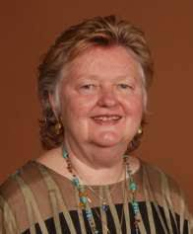
Dr. Mary Jo Bulbrook started her career as a pediatric nurse in Cincinnati, OH and moved into community college teaching in Texas. From there she got her doctorate in college teaching at North Texas State University with a minor in clinical specialist in psychiatric mental health nursing at Texas Woman’s University.
She was recruited to University of Utah where she was director of psychiatric mental health nursing and served on the university wide research committee.
In addition Occumpational Health interdisciplinary grant was achieved where she represented nursing’s contribution. Her work included international development when she was asked to head up the nursing department at Memorial University of Newfoundland in St. John’s, Nfld, CA.
She returned to USA to care for her father after her mother passed and started a career in Complementary and Alternative Medicine practice and education. Her CAM modalities included Healing Touch, Therapeutic Touch, Touch for Health, Energy Psychology and Transpersonal Psychology. Dr. Bulbfrook is a medical intuitive and founder of Transform Your Life through Energy Medicine (TYLEM). TYLEM is based on her distinguished 36-year career as a university professor and clinical specialist in psychiatric mental health nursing. This work was taken to Asutralia, New Zealand, South Africa, Peru, Ireland and Chile as well as throughout the USA and Canada.
From 1974-84, she was a key figure in the development of world- renowned family therapist Virginia Satir's teaching organization, Avanta Network. Drawing on their 12 years together, elements from Virginia's teachings and philosophy were integrated with Dr. Bulbrook's holistic nursing theory Healing From Within and Without. Over the next decade, Dr. Bulbrook's therapy training evolved into the Energetic Healing Program. In 2004, the title of the program was changed to its' current name, representing the growth and expansion from the original model.
Over the last five decades, Dr. Bulbrook has been a pioneer in the energy medicine field. She began teaching and practicing Therapeutic Touch and Touch for Health in the seventies, and moved to teaching her own energy material in the eighties. From 1990-2004, Dr. Bulbrook was active in the leadership of Healing Touch. She developed both HT and her own program in Australia, New Zealand, South Africa, Peru, Ireland and Chile, as well as throughout the US and Canada. Mary Jo has collaborated with international healers such as Rosalyn Bruyere, Credo Mutwa (South African Sangoma), Bob Randall (Aborigine elder), and Rose Pere (Maori Tohuna). In 1989, Dr. Bulbrook was honored with the Canadian Holistic Nurse of the Year award. From this rich background, she was able to create a highly effective and easy to implement model of advanced psycho- spiritual treatment and multi-dimensional health and healing.
Dr. Bulbrook has been active on various board of directors in nursing, Healing Touch, Energy Psychology, Touch For Health, American Holistic Nurses Association, Canadian Holistic Nurses Association and founded the Australia Holistic Nurses Association.
Her worldwide connection with indigenous healers, nursing, psychology and educational leadership and reform focuses her to be in a position of leadership that is inclusive, innovative and inspirational.
Prof. Medani P. Bhandari, PhD
Senior Vice President – Chief Academic Officer
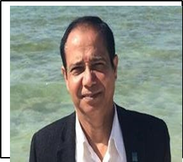
Prof. Medani P. Bhandari has been serving as Director of Sustainability Studies at Akamai University as well as a Professor and Advisor of the Chancellor – Gandaki University, Pokhara, Nepal; professor of inter-disciplinary Department of Natural Resource & Environment and Professor at the Department of Finance, Innovation and Entrepreneurship, Sumy State University (SSU), Ukraine.
Dr. Bhandari is also serving as Editor in Chief of International Journal - The Strategic Planning for Energy and the Environment (SPEE), Denmark, The Netherlands, USA- ISSN: 1546-0126 (Online Version), ISSN: 10484236 (Print Version)
https://www.journal.riverpublishers.com/index.php/SPEE/about He is also serving as managing editor at the Asia Environment Daily, (the largest environmental journal of the worldhttps://asiaenvdaily.com/index.php/editorials-2/2-uncategorised/29760-about-asia-environmental-daily
He holds M.A. Anthropology (Tribhuwan University, Nepal), M.Sc. Environmental System Monitoring and Analysis (ITC-The University of Twente, the Netherlands), M.A. Sustainable International Development (Brandeis University, Massachusetts, USA), M.A. and Ph.D. in Sociology (Syracuse University, NY, USA).
Dr. Bhandari has spent most of his career focusing on the Social Innovation, Sociological
Theories; Environmental Sustainability; Social Inclusion, Climate Change Mitigation and Adaptation; Environmental Health Hazard; Environmental Management; Social Innovation; Developing along the way expertise in Global and International Environmental Politics, Environmental Institutions and Natural Resources Governance; Climate Change Policy and Implementation, Environmental Justice, Sustainable Development; Theory of Natural Resources Governance; Impact Evaluation of Rural Livelihood; International Organizations; Public/ Social Policy; The Non-Profit Sector; Low Carbon Mechanism; Good Governance; Climate Adaptation; REDD Plus; Carbon Financing; Green Economy and Renewable Energy; Nature, Culture and Power.

Dr. Bhandari’s major teaching and research specialties include Sociological Theories and Practices.
Environmental Health; Research Methods; Social and Environmental Innovation; Social and Environmental policies; Climate Change Mitigation and Adaptation; International environmental governance; Green Economy; Sustainability and assessment of the economic, social, and environmental impacts on society and nature. In brief, Dr. Bhandari has sound theoretical and practical knowledge in social science and environment science. His field experience spans across Asia, Africa, the North America, Western Europe, Australia, Japan, and the Middle East. Dr. Bhandari has published several books, and scholarly papers in international scientific journals. His recent books are Green Web-II: Standards and Perspectives from the IUCN (2018); 2nd Edition 2020; Getting the Climate Science Facts
Right: The Role of the IPCC; Reducing Inequalities Towards Sustainable Development Goals: Multilevel
Approach; and Educational Transformation, Economic Inequality – Trends, Traps and Trade-offs; Social Inequality as a Global Challenge, the Unbeatable Challenges of Inequality, Perspectives on Sociological Theories, Methodological Debates and Organizational Sociology. Additionally, in creative writing, Dr. Bhandari has published 100s of poems, essays and published two volumes of poetry with Prajita Bhandari.

Dr. Owen Ngozi Owunwanne, PhD, CMRM, MA, MBA, EFM
Secretary / Treasurer / Executive
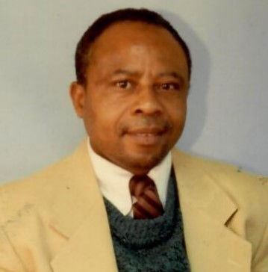
Dr. Owunwanne earned his Ph.D. in Applied Psychology with a concentration in Psychophysiology and Health Psychology at the Akamai University in 2011; M.A. degree in Psychology with a concentration in Health Psychology at the Saybrook University California in 2005; MBA degree in Health Administration at the University of Beverly Hills California in 1982; B.S. in Business Administration with a concentration in Personnel Management at the State University of New York Buffalo New York in 1978, and a Diploma in Education for the Ministry (EFM) at St. John's Lafayette square Church in Washington District of Columbia in 1997.
Dr. Owunwanne is a school teacher at Montgomery County Public Schools in Maryland. He worked for Delta T Group, a Health Care Service Agency, Maxim Health Care Services as a Therapeutic Behavioral Aide, a school registrar for Washington District of Columbia Public Schools. He served on the grading and reporting development committee for Middle School students. He served on the school curriculum for student youth services in the Washington District of Columbia. He served as Co-Director and a Policy Advisor, UNICEF-United Nations Association, Global Classroom in District of Columbia area for over 1,900 teachers and students.
Since 2013 Dr. Owunwanne has been lecturing at Howard University College of Pharmacy, teaching CAM therapies as applicable to chronic diseases such as kidney problems, urinary tract problems, prostate problems, musculoskeletal disorders, arthritis disorders, metabolic disorders. Dr. Owunwanne is the author of the Pain Patients' Perceptions of Selected Conventional, Alternative, and Integrative Medical Treatments in Pain Management.
He studied HeartMath Intervention Program at HeartMath Institute in California in 2013, where he earned a professional HearthMath license to practice the HearthMath Intervention Behavioral Health program as a provider. He received training as a Certified Medical Revenue Manager(CMRM) at the Medical Revenue Management Association of America(MRMAA) and holds Medical Revenue Management license with American Business Systems(ABS) in 2020. Dr. Owunwanne is the owner of ONJO Medical Solutions. He specialized in Medical Practice Management, Revenue Cycle Optimization, and Private Practice Business Support.
Furthermore, he specialized in making Medical Practice more streamlined and profitable. Dr. Owunwanne has demonstrated effective and efficient cash flow for thousands of practices using his company's processes and systems. He performs Complimentary Practice Analysis to show practices in more detail the impact of their training. He helps Medical Practitioners increase their revenue, provides innovative solutions to get physicians paid more and faster. He helps Medical Practitioners spend more time with patient care than paperwork. He helps Medical practitioners with Billing and Coding, assisting them with Errors and Omissions, explaining benefits (EOB), etc.
Dr. Owunwanne accomplishes these processes by conducting regular Zoom meetings, conferences, and in-person consultations with healthcare providers. He offers these services world wild to Health Care Providers who can be connected to ONJO Medical Solutions and receive assistance. Dr. Owunwanne is the owner of the Owen Community Healthcare Center, Inc, 501(C)(3) nonprofit organization providing Mental Health Services in Silver Spring, Maryland as a Life Coach to individuals suffering from anxiety, stress, anger, pain, fear, and emotional depression. Dr. Owunwanne owns ONJO Financial Services Corp, a Small Minority Business Staffing Company in Silver Spring, Maryland. For over 20 years with experience in the staffing industry, he has been committed to fulfilling agencies' requirements efficiently and effectively. Whether companies need permanent staffing, customized recruitment campaigns, project services, or contract staff augmentation, he provides and delivers experienced, proven professionals to such companies.

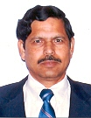
Dr. Niranjan Ray, B.S.E.E. (Hons.), M.S.E.E., Ph.D. (Engineering)
Vice President for Universiy Development
Dr. Ray is a Program Director of Corporate Training (Six Sigma), and Deputy Program Director for the Akamai University Business Administration Program. He is President of Roswell 83, LLC (3 star hotel, Motel 6), and serves on the Board of Directors of 101 Crescent, Inc. (3 star hotel, Quality Inn & Suites). Dr. Ray received his B.S.E.E (Hons)., M.S. E.E. and Ph.D. (Engineering) from Jadavpur University in India. He has taught at several universities including Jadavpur University, India, Engineering University, Bangladesh and International Institute of Management Science, India. He served as a Faculty Head of Computer Division of the Indian Institute of Material Management, Kolkata, India. He was an adjunct faculty of University of Redlands, California and Greenwich University, Norfolk Island. He served as a Principal Adviser, Software Design and Development of EDSA Micro Corporation., USA. As a corporate trainer he taught Managers, Engineers of Parsons Corporation, USA in Relational Database Management System (DBMS). He also provided training on courses of Computer and DBMS to Managers, Engineers of State Electricity Board, Kolkata, India, and Indian Administrative officers at Administrative training Institute, Kolkata, India. He is a Competent Toast Master (CTM) of Toast Master of International, USA. Dr. Ray was a senior member of IEEE, USA. He has a number of published papers to his credit. His primary interests are in teaching and research in the fields of Computer Science and Engineering, Management Information Systems, Computer Applications in Business Administration including Project Management, and Systems Analysis and Design. Dr. Ray joined the Akamai University faculty during 2002 and as such has been considered a founding member of the AU academic team.

Dr. Gregory Pacific – Member at Large – Community Projects
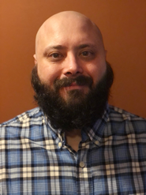
Gregory D. Pacific was born and raised in Bridgeport, Connecticut. He is a graduate of Fairfield College Preparatory School. In 2004, he earned his Bachelors with a double major in English Literature, concentration in American Literature, and Education, and a minor in Sociology. He graduated Magna Cum Laude from Manhattanville College in Purchase, New York. Greg then earned his Masters of Science degree in Teacher Leadership from Walden University. Additionally, he earned a Doctor of Philosophy Degree in Educational Leadership, with a focus on inner-city education, from Akamai University.
For the past 18 years, Greg has been an English teacher in the Bridgeport, Connecticut public school system. In 2015, he was the recipient of the Theodore and Margaret Beard Excellence in Teaching Award, one of the largest teaching awards in the country. He is a member of the United States Coast Guard Auxilliary.
In his role as a classroom teacher, Greg works with many disadvantaged students incorporating real life scenarios and culturally relevant literature into his lessons. He also serves on the Board of Akamai University and as a member of the faculty.
Greg currently lives in Milford, Connecticut with his wife Katrina, who is also a Bridgeport public schools teacher, and their two daughters, Nicoletta and Concetta.
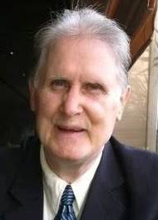
Dr. Douglass Capogrossi
Professor Emeritas & Akamai University Historian
Dr. Capogrossi is the founding president of Akamai University in 2002 and CEO setting the stage for international education online using innovative approaches to the nature of the human condition. His latest scholarly contribution is from the AU new textbook titled: Educational Transformation. (2019)
He has established and administered a variety of formal and non-formal education programs including distance learning colleges, trade apprenticeships, correctional education programs, work experience projects, on-the-job training ventures within industry and the human services, cross-border university affiliations, distance learning training programs for industry, and adult job training through center-based programs. He holds permanent teaching credentials in the United States in commerce and social studies, and lifetime certification as a counseling teacher for the emotionally disturbed. In addition he served as President with two distance education universities prior to co-foundling Akamai University.
Dr. Capogrossi has 20 years experience developing and delivering successful correctional education programs for adult inmates in Hawaii prison facilities with emphasis in parenting, cognitive development, transition to work and community, and adult basic education skills.
Dr. Capogrossi is an experienced community service administrator, where his expertise rests primarily with creation of NGO corporate structures, program funding, excellence of Board operation, and implementation of a wide spectrum of government and nonprofit training programs and emergency services projects. Dr. Capogrossi has held top management positions in industry, serving as General Manager of Micrographic Systems, a medical camera-manufacturing firm in Silicon Valley California for a brief period in the early 1980s and he owned and operated America Builders, a successful licensed general contracting firm. Dr. Capogrossi has extensive community service experience on NGO boards and is highly experienced with founding activities for new nonprofit ventures, especially with antipoverty programs.
He has served as a member of the Board of an international quality assurance agency in higher education. Dr. Capogrossi earned his Bachelors in Business Administration, his Master's in Curriculum and Instruction, and his Ph.D. in Adult and Continuing Education from Cornell University, USA, where he completed an extensive dissertation investigating the effectiveness of the American education system. Among his more recent published scholarly papers, The Assurance of Academic Excellence among Nontraditional Universities was published in the Journal of Higher Education in Europe. Dr. Capogrossi has dedicated his career in service to humanity, through his efforts to improve the human condition.
Dr. Christine Bair, PhD, ThD, RN, LPC, LFT, Advisory Council
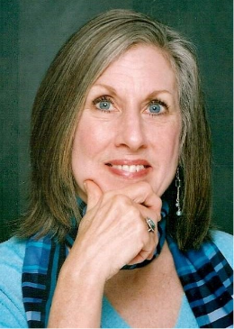
Academic / Assistant to Dean Integrative Medicine College
Residing in Virginia Beach for 25 years, provided exposure to Edgar Cayce’s ARE as well as opportunity to complete a BA at Virginia Wesleyan University with a dual major in Religious Studies and Philosophy, and later a Master’s degree in Counseling Psychology and two years post Master’s training in Spiritual Direction at Regent University and its Institute for Clinical Theology. During this time she continued working in Emergency Departments as an RN and at a state mental hospital as a supervisor. In the 90’s she was an instructor for the City of Virginia Beach’s Emergency Medical Services, specializing in the effects of critical incident and cumulative stress, and training and leading Critical Incident Stress Management teams in VA and NC. In the mid-90’s and licensed as a professional counselor and marriage and family therapist, she created a new model of counseling practice settings within local churches, avoiding the “managed care” insurance industry while providing high level professional counseling and spiritual integration. Simultaneously she served at the state conference level of the United Methodist Church developing Spiritual Leadership training.
Professor Bair entered Holos University Graduate Seminary in 2003, completing dual doctorates in Energy Medicine and Spiritual Integration in 2006, and receiving ordination. Later she served as co-chair of the Board of Directors for six years (2008-2014), followed by a faculty appointment as Director of the School of Integrative Medicine and professor of Heart Meditation (2014-2018). Her research documenting The Heartfield Effect©--the biofield synchronization of heartbeats between persons producing measurable shifts of both physical and psychological measures—was published in the peer reviewed journal, Advances in Mind Body Medicine. As a presenter and keynote speaker at multiple ISSSEEM and ACEP conferences and writer for holistic publications, she continued advocating for the expansion of healthcare to awareness of the connections and relationships within the personal dimensions of B/M/S, between persons, the larger social and cultural settings, environment, and Earth herself, orchestrated by the primacy of the heartbeat as the vibrational director/regulator of life processes.
With the publication of her first book, The Heart Field: What it is. How it works. Why it matters. (2016), Christine expanded the reach of this new paradigm of wellness in creating an overview summary of the quantum science, the particular applications at each level of physical, mental, emotional, and spiritual well-being, and the connection of the personal and collective human consciousness in language accessible to the lay public.
Continuing her work at the intersection of science and spirituality, with quantum science and universal wisdom teachings in application to health and wellbeing, Christine joined the faculty of Akamai University in 2018 and focuses on the roles of consciousness, bioenergy, the heart field, and the holographic realities of life both human and planetary.
Author of The Heart Field: What it is. How it works. Why it matters (2016), Dr. Bair translates biofield science and ancient spiritual principles into a wholistic perspective of wellness, she has worked for over four decades in a wide variety of clinical healthcare, academic, and private practice settings. Credentialed and experienced in allopathic and esoteric theory and practice, she focuses on the primary role of consciousness and the Heart Field as the connecting link between body/mind/spirit. Specializing in understanding relationships, Christine facilitates transformation of life stress into personal growth and experienced wellness. Author of cutting-edge research in the field of Energy Medicine and Spiritual Healing, Christine is dedicated to education and research into mind-body-heart biofield-based medical interventions which use consciousness and energy as primary modalities.
Dr. Rhonda Yates Chairperson of Alumni Council
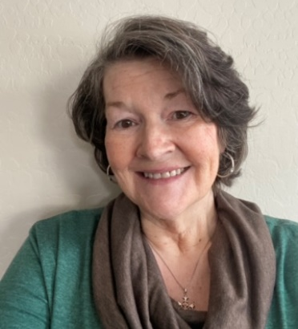
Dr. Yates has a 30-year background in Counseling as well as in Whole Person Health. She has worked in these capacities as a contract provider for the State of New Mexico Children Youth and Families Department, Belen Independent School District, Los Lunas Independent School District, as well as through private practice. She also has provided energetic healing modalities and therapies for a contractor for the Department of Defense at Fort Bliss Army U.S.Base as well as through her private practice.
She also has a deep background in business and an entrepreneurial, having developed and operated several businesses as well as supporting other highly successful entrepreneurs for 40+ years. Dr. Yates also has a deep interest in spirituality. She has spent her life attempting to model her beliefs and values through involvement with community service organizations, caring for her family and for the many individuals who have found their way to her in need of various forms of healing and/or support.
Her educational accomplishments include a Bachelor’s degree in Business Administration from Dallas Baptist University, a Master’s Degree in Counseling from Webster University and a PhD in Energy Psychology from Akamai University. On a personal level, she enjoys reading, learning, spending time with her family and serving others in whatever capacity she is able.

