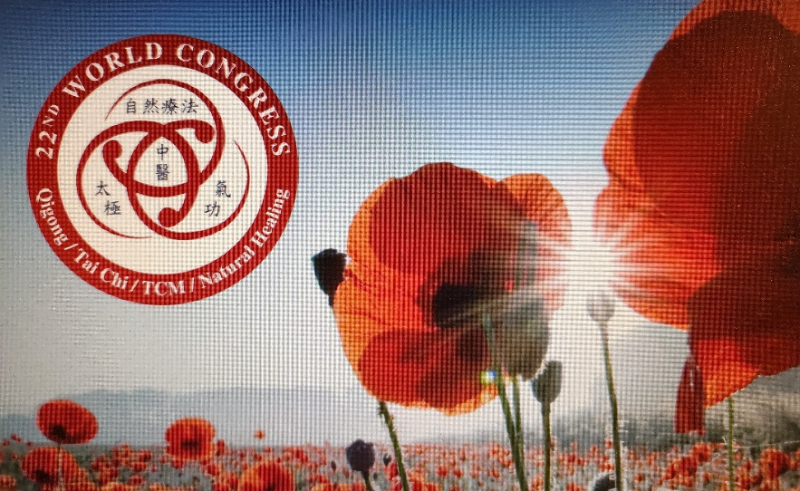
The 22nd World Congress on
Qigong / TaiChi / Traditional Chinese Medicine / Natural Healing
Celebrating Life!
Healing Spirit, Mind & Body
through Integrative Health

Congress September 24-27, 2022 A FREE Event
(Donations Appreciated)
Optional Sponsorships & Continuing Education

Coordinated by East West Academy of Healing Arts,

Global Dragon Television, Energy Medicine Partnerships,

(Co-Founders of Global Healing Alliance) & Akamai University

CALL FOR SPEAKERS / PRESENTERS / PAPERS
Dear Friends and Colleagues,
Grandmaster Dr. Effie has provided leadership for 22 years of the World Congress making significent influences on health and well being focusing on healing the Self, Community and that Planet.
Practitioners, educators and researchers of Qigong, Tai Chi, Traditional Chinese Medicine, Natural Healing and Complementary Integrative Health are in a prime position to lead the way to a new paradigm of healing that encompasses body, emotion, mind, spirit including planetary healing through channeling of life-giving Qi with love and compassion, combined with new scientific research.

Dr. Chow and I are inviting you to be a part of the 22nd World Congress. Please email me directly: bulbrookgha@gmail.com. I will bring to the organizaing committee your intent to participate. For further information please call me at: 1.919.808.8596 on a dedicated line.

Please complete and submit the intent to participate for “Call for Speakers / Presenters / Papers" by 6/27/22. You will be notified of acceptance on or before 6/30/22.

Congress Details:
Pacific Times:
Sat. Sept 24 Opening Exercises 8-9 am, Grand Opening Ceremony 9-1pm Featured presentations by Invited speakers (25 mins.). Saturday Evening Gala Celebration Award Ceremony 7-10 p.m.
Sun. Sept. 25 8-9 exercises, 9-5:30 p.m. Presentations by Invited speakers (25 mins.)
Please select the best times for you to present.
Mon. Sept 26 and Tues Sept. 27, Full-day (9am-6pm) or Half-Day (9am-1pm or 2pm to 6pm). All presentations will be in English. (Please provide your own translator.)

Featuring: Past years' Awardees will be honored at Saturday Sept. 24 Gala Celebration Award ceremony. Please publicize this event to your Circle of Influence!

Virtual Raffle Event: For additional publicity for you, we will also have a virtual Raffle event, where you can donate a book, video, session etc. Please let me know details beforehand. Title of product or service and ordinary cost. There can also be live Interviews given by a host with Global Dragon Television - Rose Hong, Founder/Director.

REQUIREMENTS:
- The abstract form sent by email attachment.
- Clear Color Head Shot Photo
There will be CEUs (Continuing Education Units) given by Akamai University by Dr. Mary Jo Bulbrook, President and Dean, Integrative Health College. Akamai University offers Innovations in education guiding practice and research to address worldwide health and wellness.
Book Series -You will also have an opportunity to submit a Full Paper 3000 to 5000 word document plus photos, if you wish to be considered for publication. This will feature your practice and discipline and offer publicity for your products or services.
If you have any suggestions for potential Sponsors, please let me know. Sponsors receive a worldwide opportunity to publicize their company and services.
Please feel free to contact Dr. Chow or me if you have any questions. Thank you very much for your quick response ASAP.
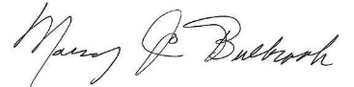
Warmest wishes,

Dame Dr. Effie Chow, PhD, RN, DiplAc (NCCAOM), LicAc (CA), Qigong Grandmaster, Congress Chair

Dr.Mary Jo Bulbrook, RN, EdD, CEMP/S/I, HTCP, ICF, Congress Co-Chair

Attachments (3): Faculty Data Form, Presentation Abstract, Presenter Agreement

FACULTY DATA FORM

Presenter Information:
Please list your name, title, and affiliations/organizations exactly as you want them to appear in the conference brochure and on your name badge.
Example: William E. Roberts, M.D., Chief of Surgery, St. Joseph’s Medical Center, Los Angeles, CA
Full Name:
Professional Designations:
Academic Affiliations:
Institution(s) and Position(s)
Corporate Affiliations:
Company name and Position

Contact Information:
Organization:
Address:
City/State/Zip:
Country:
Phone: (Day) (Eve)
Fax:
E-mail:
Web Site:

Audio / Visual Requirements:
(Support needed for preparation of your materials)
Brief Biography (55 words or less):

Full Resume: (Please Attach)

PLEASE RETURN COMPLETED FORMS BY June 27, 2022:

Dr. Mary Jo Bulbrook, CEO of Global Healing Alliance

Email: bulbrookgha@gmail.com Phone 1.919.808.8596 cell

PRESENTATION ABSTRACT
1. Brief Description of Presentation (55 Words or less): What you supply below will be used for informational and promotional purposes in the congress brochure. Please submit this portion electronically by email to the address below.

2. Presentation Title:
3. Presentation Description (approximately 100 words):

4. Goals and Objectives:
1)
2)
3)
5. Outline of Presentation with Timeframes (Please attach)

6. Full Paper (Please attach by August 1, 2022)

PLEASE RETURN COMPLETED FORMS by June 27, 2022

PRESENTER AGREEMENT FORM
My signature below confirms my agreement to present at the 22nd World Congress on Qigong/TaiChi/TCM/Natural Healing, September 24-27 2022, a Worldwide televised Virtual event.

Additionally this signed letter will give authorization to the 22nd World Congress on Qigong/TaiChi/TCM/Natural Healing and the East West Academy of Healing Arts or designee to use your name, lecture notes, lecture abstracts, photos/video and/or audio recordings of the lecture (or interviews/discussions) in educational materials, publications, web sites or advertising associated with this or future conferences.

All presenters are required to submit the following:
Please forward these by June 27, 2022

- Faculty Data Form
- Presenter Abstract/Paper Form
- Presenter Agreement Form with
- Color Head Shot photograph

I, _______________________________________ agree to present at the 22nd World Congress on Qigong/TaiChi/Traditional Chinese Medicine/Natural Healing on September 24-27, 2022 and to the terms and conditions as noted above. 22nd World Congress on Qigong/TaiChi/Traditional Chinese Medicine/Natural Healing reserves the right to schedule all speakers and presentations, or make any changes or cancellations as needed to the congress agenda.

Print Name:

Signature:

Date:

To prepare your materials to be press ready for the Congress book, we would like to ask you to submit your presentation in word format:
1. The abstract: around 200 words
2. The text: 3000-5000 words.
3. Professional Bio: 300-400 words
4. A professional photo
5. Your contact information for patients (website, email and phone).

