2021 ACADEMIC COUNCIL
Introduction
Academic Council Bylaws
2021 Academic Council Membership and Leadership
2021 Academic Council Biographies
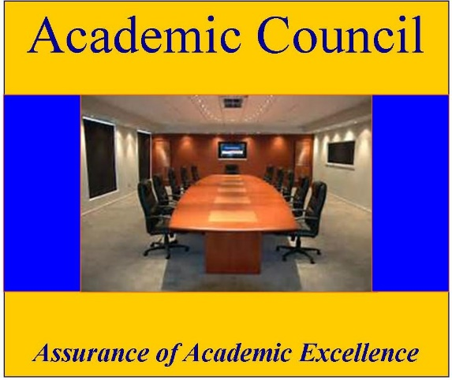
Current Description
The Council is now composed of 8 voting members and the most recent past Chair or Vice Chair and up to three alternates. Members are selected from among faculty in good standing from the degree programs at Akamai University. As many as three alternatives are selected to fill vacancies, should they arise. The Council has extensive advisory powers and responsibilities for all academic activities of the University, including curriculum and instruction, research, academic support and outreach and recruitment. The Council oversees the quality of conduct of on-going academic programs and advises relative to elimination of existing programs.
It investigates and recommends new and revised academic standards, policies and procedures for consideration and approval by the University's Board of Directors. The Council always follows a consensus approach for decision making in its meetings and carries out its activities in compliance with the University's Cde of Ethics and Professional Behavior. Each November, or as soon as possible thereafter, the Academic Council holds its organizational meeting and elects’ officers for the coming year.
Background History: The Academic Council was founded by the initiative and leadership of Dr. LaWanna Lease Blount, Dr. Anthony Maranto, and Dr. Douglass Capogrossi in 2003. As the Council elected new Chairs, Dr. James Wear and Dr. Deryl Gulliford were both able to contribute greatly in moving the Council toward a more effective body within the structure of the University. In 2012, Dr. Mary Jo Bulbrook moved the Council further toward an effective advisory body, helping to initiate the Institutional Review Board and new standardized classes for the doctoral research functions of the University. Dr. Sandra Kolbl-Holman lead the Council forward professionally and helped integrate further the work of the Council and Board of Directors. The University greatly appreciates the work of these Council Chairs over the early years in the development of the Akamai University Academic Council.
2021 ACADEMIC COUNCIL MEMBERSHIP AND LEADERHSIP
Dr. Christine Bair, Chair
Dr. Harvey Menden, Vice Council Chair
Dr. Niranjan Ray
Dr. Henry Zeidan
Dr. Medani Prasad Bhandari
Dr. Owen Owunwanne
Dr. Vijay P Gupta
Dr. Traian D. Stanciulescu
Dr. Nirmal Kumar Sharma
2021 ACADEMIC COUNCIL BIOGRAPHIES
Christine Bair, RN PhD Council Chair
AU Faculty Council, Institute for CAM Studies, Deputy Director, Chairperson of Faculty Council
Residing in Virginia Beach for 25 years, provided exposure to Edgar Cayce’s ARE as well as opportunity to complete a BA at Virginia Wesleyan University with a dual major in Religious Studies and Philosophy, and later a Master’s degree in Counseling Psychology and two years post Master’s training in Spiritual Direction at Regent University and its Institute for Clinical Theology. During this time she continued working in Emergency Departments as an RN and at a state mental hospital as a supervisor. In the 90’s she was an instructor for the City of Virginia Beach’s Emergency Medical Services, specializing in the effects of critical incident and cumulative stress, and training and leading Critical Incident Stress Management teams in VA and NC. In the mid-90’s and licensed as a professional counselor and marriage and family therapist, she created a new model of counseling practice settings within local churches, avoiding the “managed care” insurance industry while providing high level professional counseling and spiritual integration. Simultaneously she served at the state conference level of the United Methodist Church developing Spiritual Leadership training.
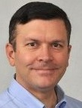
Harvey Menden, Ph.D., MBA
Council Vice Chair
Dr. Menden is Director, Training and Organizational Development for a multi-billion dollar business. He previously held the position as a Senior Consultant for the Human Resources Organizational Capability Group at Amoco Corporation. He has provided services as either an employee or an external consultant to Fortune 500 companies such as The General Electric Company, The Coca-Cola Company, Black and Decker, Canada Life, and Little Tikes. He possesses extensive experience within Human Resources, Organizational Development, Organizational Behavior, International Business, and Adult Education. Dr. Menden is a member of the International Society for Performance Improvement (ISPI) and has previously served on the Atlanta chapter's board. He serves as adjunct faculty at Newport University. Dr. Menden received his Ph.D. in Business Education from International Institute for Advanced Studies, D.Min. from CBCS, an MBA from Newport University, and a BS in Political Science from the State University of New York.

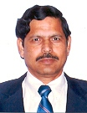
Niranjan Ray, B.S.E.E., M.S.E.E., Ph.D. (Engineering)
Dr. Ray received his B.S.E.E., M.S. E.E. and Ph.D. (Engineering) from Jadavpur University in India. He has taught at several universities including Jadavpur University, India, Engineering University, Bangladesh and International Institute of Management Science, India. He served as a Faculty Head of Computer Division of the Indian Institute of Material Management, Kolkata, India. He was an adjunct faculty of University of Redlands, California and Greenwich University, Norfolk Island. He served as a Principal Adviser, Software Design and Development of EDSA Micro Corporation., USA. As a corporate trainer he taught Managers, Engineers of Parsons Corporation, USA in Relational Database Management System (DBMS). He also provided training on courses of Computer and DBMS to Managers, Engineers of State Electricity Board, Kolkata, India, and Indian Administrative officers at Administrative training Institute, Kolkata, India. He is a Competent Toast Master (CTM) of Toast Master of International, USA. Dr. Ray was a senior member of IEEE, USA. He has a number of published papers to his credit. His primary interests are in teaching and research in the fields of Computer Science and Engineering, Management Information Systems, Computer Applications in Business Administration including Project Management, and Systems Analysis and Design.
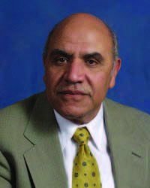
Henry Zeidan, Ph.D.
Dr. Zeidan received his Ph.D in Biomedical Sciences Biochemistry at The University of Hawaii, School of Medicine in 1979. He did his postdoctoral training in Medicinal chemistry and Pharmacognosy at the Medical Center of The University of Illinois, School of Pharmacy. Dr. Zeidan then joined the University of Michigan, the clinical chemistry division at Cleveland State University, as an assistant Professor of Biochemistry and Clinical Chemistry. He then joined the biomedical faculty at Atlanta University Graduate School. He served as a major Professor for five graduate students. Two received a Ph.D in Biochemistry under his mentorship. He was promoted to Associate Professor in 1988. In 1991, he moved to Life University, Basic Sciences Division and was promoted to Professor in 1996. He was known among his students as a talented professor with a chess game approach and was awarded a Ph.D? (putting him or her through) degree by numerous Professional students. Dr. Zeidan held positions as Visiting Professor in St. Matthew School of Medicine, University of Texas, Kuwait University, and Professor of Biomedical Sciences at St. Christopher's School of Medicine, Greenwich University, and Graduate School of Health Sciences. He served as a major Professor of two graduate students who obtained their Ph.D in Preventive Medicine and Human Physiology. He served as an Educational Mentor at Creighton University, School of Pharmacy, and Pharm D Program. He received recognitions as outstanding teacher, Smith Kline & French Laboratories faculty award for outstanding faculty and Fulbright Scholar. He acted as a consultant to Cairo University, National Research Center, Cairo and Kuwait University. Dr. Zeidan also acted as a clinical Laboratory Director to several Reference Laboratories. Henry is a Fellow of National Academy of Clinical Biochemistry, Diplomat of American Board of Bioanalysis, and a Fellow of the Association of Clinical Scientists. Dr. Zeidan has numerous publications. His major research focused on the application of Spin Labels in Biomedicine and Pharmacology, the molecular mechanisms of biogenic amines degradation and Sickle hemoglobin. Dr. Zeidan accepted a Position as Professor of Pharmaceutical Sciences at Nevada College of Pharmacy in 2003. Henry enjoys spending his leisure time with his dedicated wife and lovely five children. He enjoys playing tennis, swimming, traveling, chess and hunting two birds with one stone.
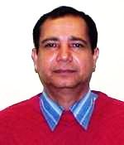
Medani Prasad Bhandari, PhD
Member
Dr. Bhandari is interested in teaching and mentoring in the field Community and Economic Development; Environmental Studies; Sustainability Studies; Peace, Diplomacy and International relations. His main interest as a teacher and researcher centers on the intersection of local and global interests (trans-society/trans-border) capacities in addressing global political economy; green economy, natural resource management challenges, environmental sustainability, and the effects of climate change. He is also interested in risk analysis, public policies, and behaviors that contribute to the goal of catalyzing action across the global community, increase public awareness and change public attitudes on global climate change; natural resource governance issues, human rights abuse, sustainable development and environmental degradation. His goal is to utilize scientific and cultural knowledge, research skills, and extensive experiences to help address the challenges of global environmental change, the green economy, and sustainability. He is also interested as well in assessing the economic, social and environmental impacts on natural resources/ environmental sustainability. His ultimate objective is to cultivate and engage multidisciplinary knowledge-based networks to minimize the impact of climate change on marginalized societies and to reduce societal conflict over natural resources.
Dr. Owen Ngozi Owunwanne
Dr. Owen Owunwanne is a school teacher at Montgomery County Public Schools in the state of Maryland. He worked for Delta T Group, a Health Care Service Agency; Maxim Health Care Services as as a Therapeutic Behavioral Aide; a school registrar for Washington District of Columbia Public Schools. He served on grading and reporting development committee for Middle School students. He served on school curriculum for students youth services in Washington District of Columbia. He served as Co-Director as well as a Policy Advisor, UNICEF-United Nations Association, global Classroom, DC area for over 1,900 teachers and students. Dr. Owunwanne graduated from State University of New York at Buffalo with B.S. degree in Business Administration. He earned his MBA in 1982 at the University of Beverly Hills California, and earned his MA degree in psychology at Saybrook University in California. Dr. Owunwanne has a PhD degree in Applied Psychology, Health Psychology, Psychophsiology from Akamai University Hilo, Hawaii in 2011. Dr. Owunwanne has over 20 years of experience in business entrepreneurship.
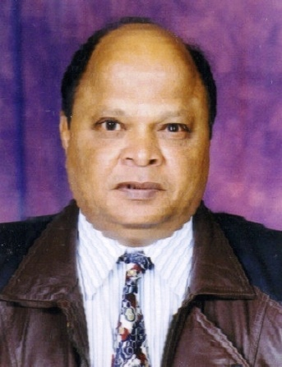
Vijay P Gupta, MD, PhD
Dr. Gupta earned his M.B.B.S. from Agra University in India, his D.F.M. in Forensic Medicine from Bangalore University, India, and his Ph.D. in Forensic Medicine and Toxicology from Greenwich University. Subsequently he did his American Board in Forensic Medicine from American College of Forensic Examiners International, Springfield,U.S.A. He was honoured with a D.Sc. from Colombo for his contributions to Forensic Medicine and Medical Education. He had worked for The Ministry of Health Saudi Arabia for more than a decade as Director Emergency and Clinical Toxicology. He is member of many international and national academic bodies including the Executive Advisory Board of American College of Forensic Examiners International, Springfield, USA. He has 48 publications to his credit and most of them appeared in International Journals. He had supervised research work of 10 medical postgraduates leading to Ph.D. and Master's degrees. Presently, he is working as Professor of Forensic Medicine and Toxicology at HIHT University, Dehradun, India.
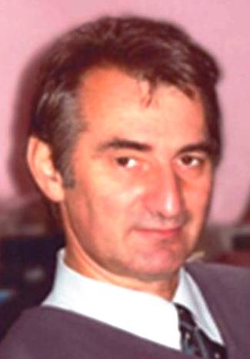
Traian D. Stanciulescu, PhD
Dr. Stanciulescu, born in 1951 (Potlogi, Romania), has an interdisciplinary academic formation: architecture & philosophy and history faculty (psychology and sociology included). He has worked as an architect, as a lyceum professor, and finally as a university professor at the University of Iai. As a scientific researcher at National Inventics Institute (1993-2008), he auto-didactically studied biophotonics and its emergent implications in the field of human health optimization, having many original contributions, theoretical and practical (inventions) also. He has didactic abilities in the field of teaching "know how"? disciplines, such as semiotics, hermeneutics, creatology, persuasion strategies, etc. which he synergetically applied in teaching and research activity. He is involved in many social-cultural events, being an efficient leader, permanently involved in public relationships by conferences, courses, etc. He has abilities in creative fields such as: poetry, music and painting, directly used for a personal "connection energy" preservation.
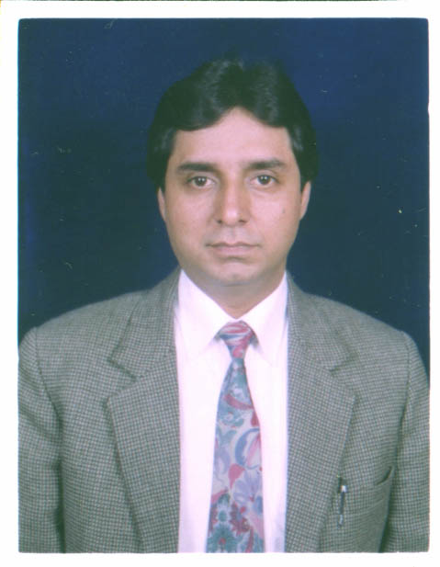
Nimal Kumar Sharma, Ph.D., MBA, LLB, MCOM, BCOM, PGDHRM, PGDMM, PGDFM.
Council Member
Prof. (Dr.) Nirmal Kumar Sharma is highly educated and has extensive qualifications in the Business stream. He has completed a Bachelor of Commerce (BCOM), Master of Commerce (MCOM), Bachelor of Laws (LLB), Master of Business Administration (MBA) and Doctor of Philosophy (Ph.D.) in Management with concentration business administration. In addition to above ultra-high qualifications Prof. (Dr.) Sharma has also completed a Postgraduate Diploma in Human Resources Management (PGDHRM), Postgraduate Diploma in Marketing Management (PGDMM), Postgraduate Diploma in Financial Management (PGDFM) and some professional development subjects. He completed all his qualifications from world's top-class universities with brilliant consistent meritorious academic records and achievements. He has a tech-savvy outlook with extensive long work experience. His experience level which he has obtained in different highly developed countries includes different academic institutions/universities, corporate houses, Fortune 500 MNC, banks, autonomous government bodies, courts, etc., Having a proven track record of successfully managing students, resources, and staff to improve educational services, thereby providing management and students with the best learning and teaching environment and opportunity to achieve their full potential. Possessing the required enthusiasm, vision, drive and adaptability necessary to manage a modern advance higher-level classroom environment. He is highly educated and experienced with multiple qualifications and specializations. His areas of expertise include Marketing Management, Financial Management, Human Resources Management, Business Administration and Management, Banking, Law and related areas. He has a deep interest in music, science, and technology, politics, games, and fitness. Professor (Dr.) Sharma could be reached at drsharmanirmal@gmail.com.
Student Representative
To Be Selected
Non-Voting Ex-Official Members
Dr. Mary Jo Bulbrook, Board President
Dr. Anthony Maranto, Board Vice President

