Dr. Mary Jo Bulbrook returns to Calgary, Alberta
Friday April 17th, Time 9 to 4:30 pm Pacific
Fee: $95 CA ($70 US) by March 17th; thereafter $120 ($90 US)
On-line fees paid by credit card only click here $55 us by March 17th & $75 after
Available online through ZOOM Connection Click Here
6 Continuing Education Units (CEU’s included in price) or 0.6 College Credit Option
REGISTRATION CLICK HERE
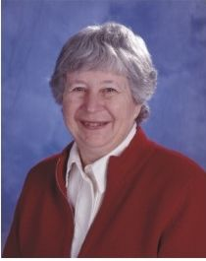
Multi-Dimensional Experiences Includes:
Sacred Ceremony honoring three nurse leaders
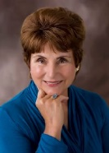
Who worked together as ONE
- Janet Mentgen - Healing Touch, Founder, HTP & HTI
- Charlotte McGuire - Holistic Nursing, Founder, AHNA
- Dorothea Hover Kramer - Energy Psychology, Co-founder, ACEP
Connecting our Energy with Theirs To Inspire our Path Forward.
Learn strategies to prevent infections from threats to our health & well-being at this session!
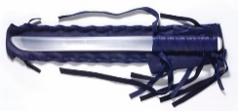
Join in the sacred ceremony of cutting cords, removing obstacles on our path, feather blessing, to renew our dedication as Healing Touch, Energy Medicine, Therapeutic Touch, Energy Psychology, Integrative Health practitioners, educators and researchers and intention setting, for our individual and collective spiritual paths.
Uniting with other healing programs, we can achieve more.
Let us end our separateness and become ONE: ONE in Spirit, ONE in Care & ONE in Commitment To all that is Sacred, Wholly and Healthy.
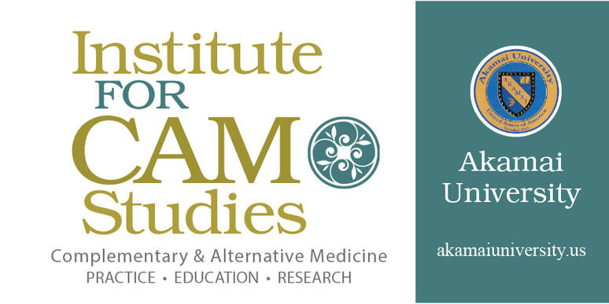
https://www.globalhealingalliance.com/cam-institute.html

Use your experiences with Healing Touch, TYLEM, Touch for Health and Energy Psychology modalities as pathways to CAM degrees as well as continuing education, Akamai University is internationally accredited under the leadership and mentorship with Dr. Mary Jo Bulbrook, RN, CEMP/S/I, HTCP, HTIP/I, ICF to add to your profile of expertise.
Attend the HTP 2020 Conference and Instructors meeting. Add to your CAM Specialist Training. Click here to connect with Dr. Bulbrook, Dean of the Institute of CAM Studies to see the possibilities.
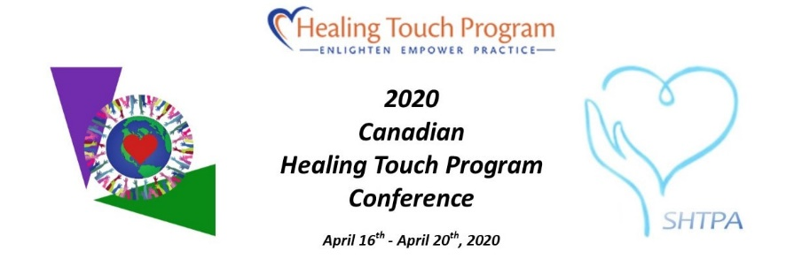

https://www.societyofhealingtouchprogramalberta.ca/2020-htp-conference.html

