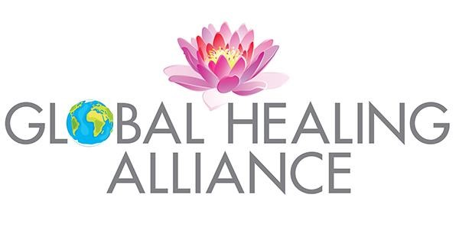
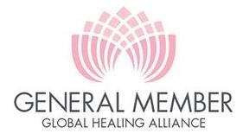
Fee $60
M
embers
hips

2022

–

202
5

Fees

Gener
al Member

Connecting with a network of the best natural healing practitioners and educators around the world.

Benefits:
Receive 10% reduction at special events and webinars.

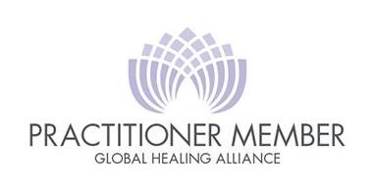
Practitioner Member

Fee $120
Have your practice information and personal profile on GHA's website.
Benefits:
- Listing of your practice information
- Personal profile on Website
- Access to GHA's special events and conferences 30% reduction.
- Invitation to Global Healing Summit / conference held annually around the world or on cruises.
- Client / student referrals from GHA.
- Professional liability insurance recommendations for qualified practitioners.
- Featured on Top Global Healers Directory E-Book published by Global Dragon TV, Rose Hong, Co-founder of GHA.

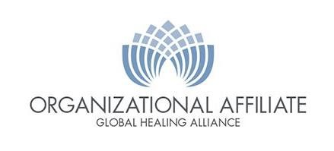
Organizational Affiliate
Connect your organization to be part of the network of movers and shakers dedicated to transform health care.
Must complete an approved affiliate organizations application and be approved.
Yearly Fees $300 Benefits:
- List your services and web site to drive traffic to your organization.
- Affiliate bonus for enrolled students who come from marketing our events from your organization $30.
- Eligible to have a booth at events at a reduced rate of 30% or a “virtual booth” at GHA events..

